NAME- Pranit Tandon

REG NO-RA1911028010014

**AIM:-** To Implement ppp configuration using routers in cisco packet tracer

**Component Used**:-

|  |  |  |
| --- | --- | --- |
| Device | Type | Quantity |
| Device | Laptop | 2 |
| Router | 1841 | 2 |
| Wires | Copper Cross Over | - |

Circuit Diagram:-

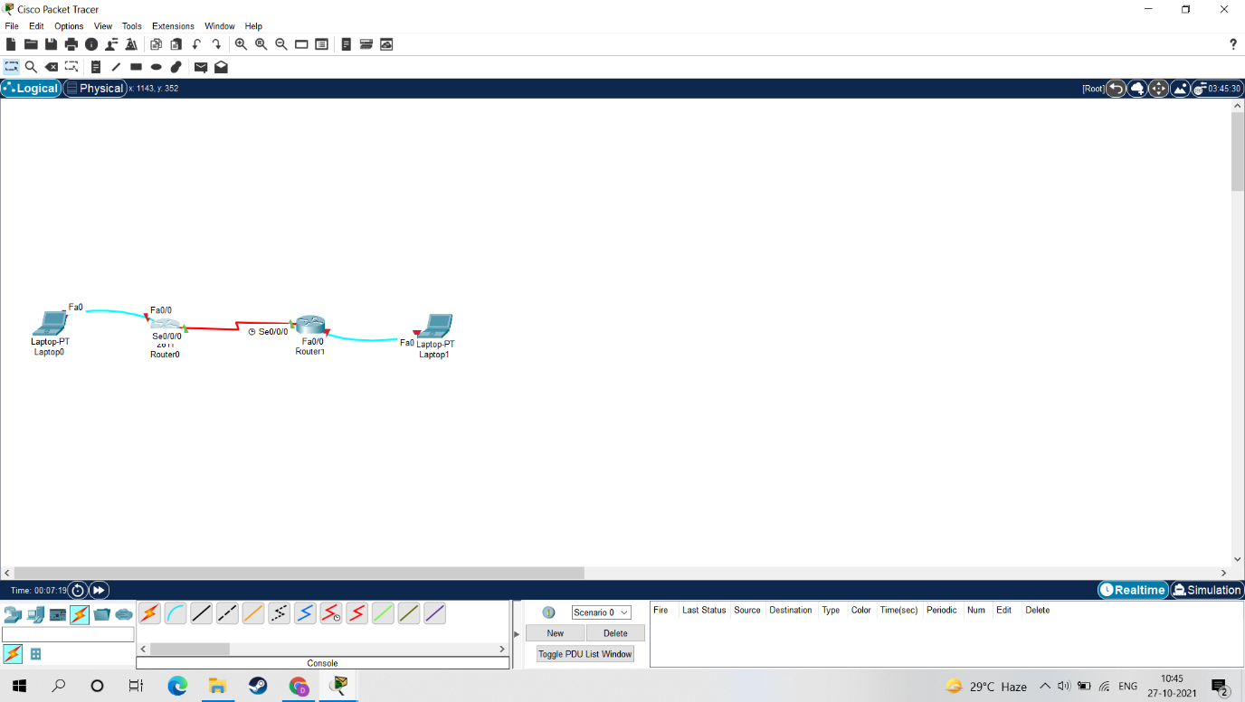

Ping Command:-

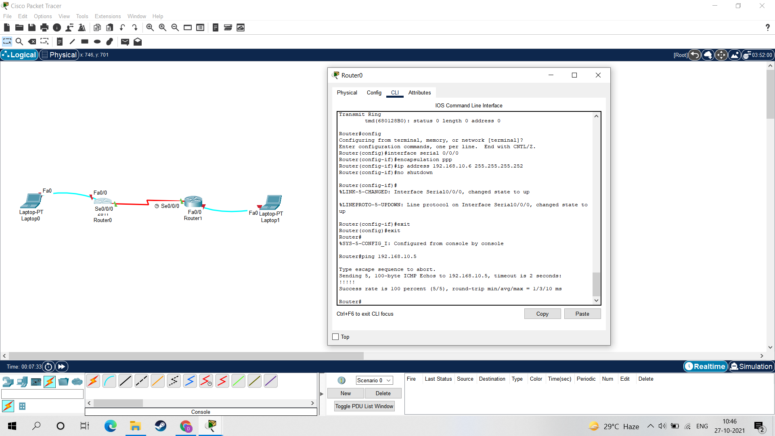

**Result:-**

Hence the PPP configuration is implemented and verified using Ping Command.